**Chapter 7**

**Second-Order Differential Equations**

**7.4. Series Solutions of Differential Equations**

**Section Exercises**

**Find a power series solution for the following differential equations.**

1. 

Answer: 

1. 

Answer: 

1. 

Answer: 

1. 

Answer: 

1. 

Answer: 

1. 

Answer: 

1. 

Answer: 

1. 

Answer: 

1. 

Answer: 

1. 

Answer: 

1. 

Answer: 

1. 

Answer: 

1. The differential equation  is a Bessel equation of order 1. Use a power series of the form  to find the solution.

Answer: 

**Chapter Review Exercises**

***True or False*? Justify your answer with a proof or a counterexample.**

1. If andare both solutions to  then  is also a solution.

Answer: True

1. The following system of algebraic equations has a unique solution: 

Answer: False

1.  is a solution to the second-order differential equation 

Answer: False

1. To find the particular solution to a second-order differential equation, you need one initial condition.

Answer: False; you need two initial conditions

**Classify the differential equation. Determine the order, whether it is linear and, if linear, whether the differential equation is homogeneous or nonhomogeneous. If the equation is second-order homogeneous and linear, find the characteristic equation.**

1. 

Answer: second order, linear, homogeneous, 

1. 

Answer: second order, linear, nonhomogeneous

1. 

Answer: first order, nonlinear, nonhomogeneous

1. 

Answer: second order, linear, nonhomogeneous

**For the following problems, find the general solution**

1. 

Answer: 

1. 

Answer: 

1. 

Answer: 

1. 

Answer: 

1. 

Answer: 

1. 

Answer: 

1. 

Answer: 

1. 

Answer:

**For the following problems, find the solution to the initial-value problem, if possible.**

1.   

Answer: 

1.   

Answer: 

**For the following problems, find the solution to the boundary-value problem.**

1.   

Answer: 

1.   

Answer: 

**For the following problem, set up and solve the differential equation.**

1. The motion of a swinging pendulum for small angles  can be approximated by  where  is the angle the pendulum makes with respect to a vertical line, *g* is the acceleration resulting from gravity, and *L* is the length of the pendulum. Find the equation describing the angle of the pendulum at time  assuming an initial displacement of  and an initial velocity of zero.

Answer:

**The following problems consider the “beats” that occur when the forcing term of a differential equation causes “slow” and “fast” amplitudes. Consider the general differential equation that governs undamped motion. Assume that **

1. Find the general solution to this equation (Hint: call ).

Answer:

1. Assuming the system starts from rest, show that the particular solution can be written as 

Answer: This is a proof; therefore, no answer is provided.

1. **[T]** Using your solutions derived earlier, plot the solution to the system  over the interval  Find, analytically, the period of the fast and slow amplitudes.

Answer:

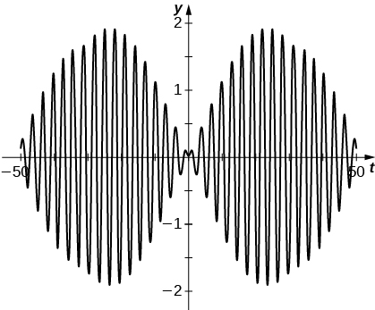

**For the following problem, set up and solve the differential equations.**

1. An opera singer is attempting to shatter a glass by singing a particular note. The vibrations of the glass can be modeled by  where  represents the natural frequency of the glass and the singer is forcing the vibrations at  For what value  would the singer be able to break that glass? (Note: in order for the glass to break, the oscillations would need to get higher and higher.)

Answer:

This file is copyright 2016, Rice University. All Rights Reserved.